SQL QUERY OPTIMIZATION
1. Objective
To analyze SQL query performance using EXPLAIN ANALYZE and improve query execution using indexing techniques.
2. Database & Tables
- Database: internship_task11
- Tables:
1. candidates
2.interview_sessions
3.Query 1 – Optimization (JOIN Filter Query)
- Before Optimization Query
EXPLAIN (ANALYZE, BUFFERS)
SELECT c.name, s.started_at
FROM candidates c
JOIN interview_sessions s
ON c.id = s.candidate_id
WHERE s.status = 'completed'
AND s.started_at > NOW() - INTERVAL '30 days';
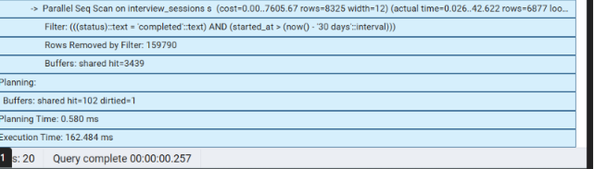
Execution Time: 162.484ms

Optimization
CREATE INDEX idx_status_startedat
ON interview_sessions(status, started_at);
- After Optimization
CREATE INDEX idx_status_startedat
ON interview_sessions(status, started_at);
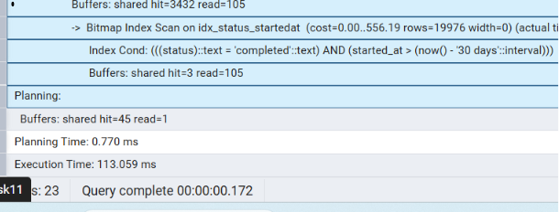
4.Query 2 – GROUP BY Optimization
- Before Optimization Query
EXPLAIN (ANALYZE, BUFFERS)
SELECT status, COUNT(*)
FROM interview_sessions
GROUP BY status;
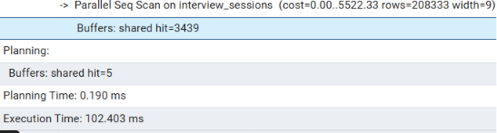
- After Optimization
CREATE INDEX idx_status ON interview_sessions(status);
EXPLAIN (ANALYZE, BUFFERS)
SELECT status, COUNT(*)
FROM interview_sessions
GROUP BY status;
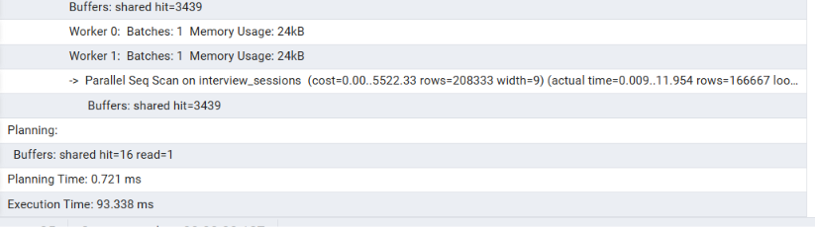
5.Query 3 – JOIN Query Analysis
- Before Optimization Query
EXPLAIN (ANALYZE, BUFFERS)
SELECT c.name, s.status
FROM candidates c
JOIN interview_sessions s
ON c.id = s.candidate_id;
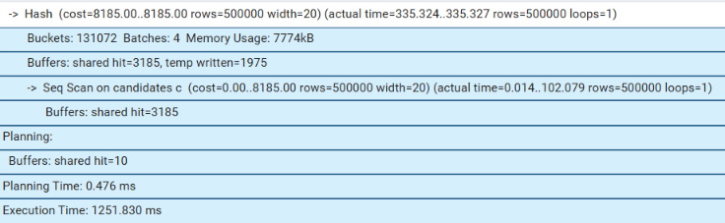
🔹 Optimization
CREATE INDEX idx_candidate_id ON interview_sessions(candidate_id);
- After Optimization Query
EXPLAIN (ANALYZE, BUFFERS)
SELECT c.name, s.status
FROM candidates c
JOIN interview_sessions s
ON c.id = s.candidate_id;

- After Optimization Result
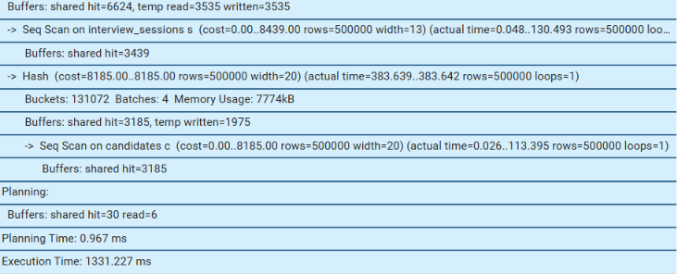
Execution Time:
1331.227 ms
6.SQLAlchemy – N+1 Problem
- Problem (Bad Code)
users = session.query(Candidate).all()
for user in users:
print(user.interviews)

- Solution (Optimized Code)
from sqlalchemy.orm import joinedload
users = session.query(Candidate)\
.options(joinedload(Candidate.interviews))\ .all()

7. pg_stat_statements
Attempted Setup
CREATE EXTENSION pg_stat_statements;
SELECT query, calls, total_exec_time
FROM pg_stat_statements
ORDER BY total_exec_time DESC
LIMIT 3;
SELECT * FROM pg_extension;
